Llandow Ward Community Council Report
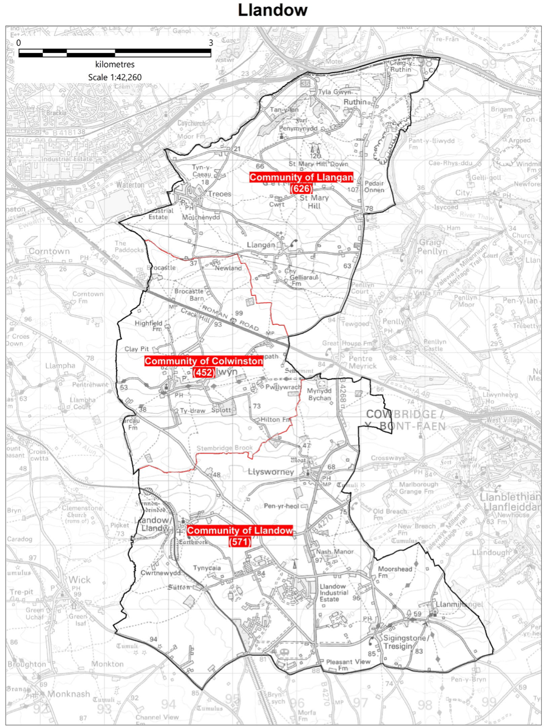
Cllr. Christine Cave email: cacave@valeofglamorgan.gov.uk
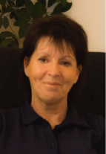
Date: November/December 2023- Report to the Community Councils (CC) in the Llandow Ward: Colwinston; Llandow, Llysworney, Sigingstone, Sutton and Llangan/Treoes and St Mary Hill.

Vale of Glamorgan Full Council meeting date for 2023/24

4th December, 2023, and 15th January, 4th March 2024, 29th April 2024.

Agenda for 4th December Full Council meeting – 6pm

Agenda

PART 1

1. Apologies for absence.

2. (a) To hear the roll call of Members.
(b) To receive declarations of interest and the nature of such interests under the Council’s Code of Conduct.
(Note: Members seeking advice on this item are asked to contact the Monitoring Officer or Democratic Services at least 48 hours before the meeting.)

3. To approve the minutes of the meeting held on 25th September, 2023.

4. Questions from the Public –
5 questions have been received.

5. To receive any announcements from the Mayor, Leader, Members of the Cabinet and the Chief Executive and to receive any petitions submitted by Members.

6. To consider the following Notice of Motion [submitted by Councillors Dr. I.J. Johnson and M.J. Hooper] –
- Bus Services in the Vale of Glamorgan
- Council notes the long-term policy of promoting integrated public transport through a Barry Docks public transport interchange, which is included within the Council’s Local Development Plan and Local Transport Plan.
- Council recognises the challenges to the bus industry in recent times, including reduction in passenger numbers following the lock-down period, driver recruitment, and the conclusion of the Welsh Government Bus Emergency Scheme subsidy in July 2023.
- Council supports the provision of a sustainable network of buses across the Vale which recognises people’s needs and not just a commercial demand-led service.
- Council requests a report, to be published and debated by Council within three months, on the development of the public transport interchange, including recommendations on how a fully functioning interchange will be provided in future.
7. To consider the following Notice of Motion [submitted by Councillors M.J. Hooper and Dr. I.J.
Johnson] –
Barry Waterfront Development
- Council notes the progress of the Barry Waterfront Development, a major housing development on the site of the old Docks, which is shared between three national (U.K.) house builders; Persimmon, Barratts and Taylor Wimpey (the Consortium).
- Council notes that the Consortium have contracted a third party to undertake much of the finishing off at the site and that the development has not been finished to the standard expected, as mandated in the planning consent, with public open spaces incomplete, road junctions that have safety issues unresolved, streets without street lighting and many hundreds of semi-mature trees left unplanted, while some of the items that are unfinished are up to four years late (Waterside Gardens).
- Council believes that the Consortium of Developers are in breach of conditions of their planning approvals, and have badly let down the residents of the Waterfront, who purchased their properties in good faith.
- Council recognises that it has failed in its duty of care towards residents by failing to enforce the conditions associated with this planning consent.
- Council determines that it will utilise all available means at its disposal (including legal action) to force the Consortium to fulfil all their obligations at the earliest opportunity, and by the end of the financial year, at the latest.
- Council will pursue recompense for Waterfront residents, by demanding that the Consortium plant the ‘missing trees’ from the development as a Community Orchard in the unusable part of the Council’s Harbour Road (overflow car park).

References –
8. Review of the Joint Consultative Forum Constitution – Joint Consultative Forum: 25th September, 2023.
9. Audited Statement of Accounts 2022/23 – Special Governance and Audit Committee: 16th November, 2023.

Report of the Director of Corporate Resources –
10. Audited Statement of Accounts 2022/23.

Report of the Chief Executive –
11. Use of the Chief Executive’s Emergency Powers.

Report of the Monitoring Officer / Head of Legal and Democratic Services –
12. Amendments to the Council’s Constitution.

13. To consider the following proposal(s) from the Executive in relation to the Council’s Policy Framework and Budget

Item | Date of Meeting | Minute No.
(a) Treasury Management Mid-Year Report 2023/24(1 & 2) | 16th November, 2023 | C152

N.B. The report which is the subject of the reference in respect of Agenda Item 13(a) above has already been circulated to Members with the Cabinet agenda for 20th November, 2023.

**Further copies are available from the Democratic Services Office if required**.

14. To inform the Council of the Use of the Urgent Decision Procedure under Article 15.14 of the Constitution.

Item | Date of Meeting | Minute No.
(a) Agreement to Enter into a Supplemental Agreement with the Developer for the Construction of New Council Apartments at Cadoxton. Barry (Part I) (2) | 5th October, 2023 | C113
(b) Agreement to Enter into a Supplemental Agreement with the Developer for the Construction of New Council Apartments at Cadoxton. Barry (Part II) (4) | 5th October, 2023 | C115
(c) The Vale of Glamorgan Community Review – Draft Proposals (5) | 19th October, 2023 | C125
(d) Agency Worker Contract Awards (Part I) (2) | 19th October, 2023 | C133
(e) Agency Worker Contract Awards (Part II) (5) | 19th October, 2023 | C137

15. To receive questions and answers pursuant to Section 4.19.2 – 4.19.9 of the Council’s Constitution (i.e. questions on any matter in relation to which the Council has powers or duties or which affects the Vale of Glamorgan).

16. Any items which the Mayor has decided are urgent (Part I).

Details of the Special Council meetings held on the 20th November, 2023

Final Draft Vale of Glamorgan Council Annual Self-Assessment Report 2022/23 –

Vale of Glamorgan Replacement Local Development Plan 2021-2036 Revised Delivery Agreement and Draft Preferred Strategy – Cabinet: 2nd November, 2023 / Environment and Regeneration Scrutiny Committee: 14th November, 2023

Amendments to the Council’s Constitution.

Members of the Cabinet
Councillor L. Burnett (Executive Leader and Cabinet Member for Performance and Resources) – Labour Party
Councillor B.E. Brooks (Deputy Leader and Cabinet Member for Sustainable Places) – Labour Party
Councillor R.M. Birch (Cabinet Member for Education, Arts and the Welsh Language) – Labour Party
Councillor M.R. Wilson (Cabinet Member for Neighbourhood and Building Services) Labour Party
Councillor M.R. Wilkinson (Cabinet Member for Public Sector Housing and Tenant Engagement) Labour Party
Councillor E. Williams (Cabinet Member for Social Care and Health) Llantwit First Party
Councillor S. Sivagnanam (Cabinet Member for Community Engagement, Equalities and Regulatory Services) Labour Party
Councillor G. John (Cabinet Member for Leisure, Sport and Well-being) Llantwit First Party

Cabinet Meetings

14th December 2023 agenda not yet available

16th November 2023 meeting minutes available at:

https://www.valeofglamorgan.gov.uk/Documents/_Committee%20Reports/Cabinet/2023/23-11-16/Minutes.pdf

Consultations - Vale of Glamorgan Council

Current consultations are available at: https://participate.valeofglamorgan.gov.uk

Social Services Consultations
We consult with individuals and groups in the Vale of Glamorgan community and aim to use this information to inform development of future policies and services.
Several local and regional partnerships have been set up - as well as various forums - to let members of the public and other organisations have a say in the way services are provided and developed.
Social Services Quality Assurance
Quality Assurance in Social Services incorporates three elements:
- Service User and Carer Satisfaction
- Case file auditing
- Development and Review of Departmental Policies, Procedures and Guidance
SSIA - Working together to improve Welsh social care
A joint enterprise between the Welsh Assembly Government, the Welsh Local Government Association and the Association of Directors of Social Services Cymru, SSIA is working with councils and partner agencies throughout Wales to improve service outcomes and efficiency across the range of social care services, driving radical change in the way services are planned and delivered.
Current programmes, delivered in close partnership with a variety of stakeholders, include developing new models of service for older people, supporting effective collaboration between agencies and an innovative national development programme for middle managers.
- Demonstrating improvement through reablement
- Annual Council Reporting Framework
- National Social Work Team Manager Development Programme
- Strategic Leadership for Collaboration
- Improving Assessment and Care Management in Adults’ Services
- Safeguarding – Adults and Children’s Services
- Information on our new work programme ‘Achieving greater efficiency in services for older people in Wales’
- 029 2046 8685
- enquiries@ssiacymru.org.uk

Have Your Say on Gypsy, Traveller and Showpeople Sites
Do you or your family need a pitch or yard in the Vale of Glamorgan?
Opinion Research Services are working on behalf of Vale of Glamorgan Council to speak to Gypsy and Traveller families in the area.
We need to find out how many pitches or sites are needed.
A law called the Housing (Wales) Act 2014 means each Local Council must then make sure those pitches or sites are built.
You are invited to take part in a survey to make sure the true accommodation needs of Gypsies and Travellers is known in the Vale of Glamorgan.

How to have your say
- Call: 01792 535319
- Text: 07471 267095
- Email: Michael.Bayliss@ors.org.uk

Local Matters
- Colwinston/Llangan/Llandow – Boundary Commission review of Town and Community Councils– letter of objection agreed - ongoing
- Colwinston – Dog Fowling – ongoing
- Colwinston – Adoption of the vines raised again with Director of Environment & Housing Services, Vale of Glamorgan Council
- Outstanding items regarding St. David’s Church in Wales school also raised with the Director of Environment and Housing Services
- Colwinston – St David’s Church in Wales School – issues were raised, and we are still waiting to hear further from the education department.
- Colwinston – The outstanding matters of the Coffin Stile (planning permission) ongoing
- Llandow relocation of the current waste recycling center –additional sites are now being considered (both located on the current Llandow Trading Estate site) and that while the ‘Place for Homes’ potential site is being evaluated these two further sites are being evaluated.
- Llandow – Hedge cutting in Sutton Road, highways in consultation with landowner to have hedgerow cut back as several complaints received from the same person re hedgerow intruding onto the highway
- Llandow – Issues raised concerning problems with highway’s officer and pavements in Llandow
- Llandow – New 20 mph causing drainage issue – raised with highways - ongoing
- Llandow – Flooding issues - Llandow members of the Llandow CC to meet and discuss way forward. Date for meeting to be agreed – ongoing
- Llandow – Site Serve – Condition 2 lifted – matter raised with Head of Planning – email response forwarded to CC for comment
- Llangan - Planning issues raised with VoG regarding Industrial development on the boundary with Bridgend CC additional time was given for responses - ongoing
- Llangan/Llandow - Leaflet developed with CC members to raise awareness of how to report traffic issues – provided clerk to Llangan CC with a named officer to support work with Gosafe Cymru
- Llangan/Colwinston/Llandow issues raised with Rob Thomas regarding the re-banding of homes in the ward – ongoing.

Scheduled Meetings for December 2023 - All Meetings commence at 6.00 p.m. and will be held virtually unless otherwise stated

Council  [View Live Stream - 4 December] | 4 Dec | Early Retirement/Redundancy (4.00 p.m.) | 6 Dec
Annual Meeting |  | Licensing - Public Protection (10.00 a.m.) | 12 Dec
Cabinet (2.00 p.m.) | 14 Dec;  21 Dec | Licensing - Statutory
Scrutiny (Corporate Performance and Resources) | 13 Dec | Licensing Sub
Scrutiny (Environment and Regeneration)  [View Live Stream - 12 December] | 12 Dec | Planning (4.00 p.m.) | 21 Dec
Scrutiny (Healthy Living and Social Care) (5.00 p.m.)  [View Live Stream - 5 December] | 5 Dec | Public Rights of Way
Scrutiny (Homes and Safe Communities)  [View Live Stream - 6 December] | 6 Dec | Senior Management Appointment
Scrutiny (Learning and Culture) | 7 Dec | Standards (10.00 a.m.)
Appeals |  | Trust
Governance and Audit | 11 Dec | Vale of Glamorgan Local Access Forum (5.00 p.m.)
Community Liaison |  | Voluntary Sector Joint Liaison
Democratic Services |  | Welsh Church Act Estate
Investigation |  | Shared Regulatory Services Joint Committee (10.00 a.m.) | 13 Dec

